Author: Anthony Sylvester

Abstract

This guide walks you through the process of installing and configuring the FreePBX phone system as a VM using VirtualBox, installing the free MicroSIP Softphone on a Windows PC or Server, registering the softphone to the PBX, and performing various tests that showcase some of the different features.

DIY Phone System Lab Guide

VirtualBox Option

Version: 1.0

Table of Contents

Background 3

Intro 4

What is this lab? 4

What is a Phone System? 4

What is a Softphone? 4

What is a DID? 4

Lab Setup 5

VM Default Info 5

Group Info 5

Network Topology 5

Setup Option 1 (1 PC or Server) 6

System Requirements 6

Setup Option 2 (2 PCs or Servers) 7

System Requirements 7

Install VirtualBox On Your Machine 8

Create the FreePBX VM 9

Download the FreePBX Distro 9

Create the FreePBX VM in VirtualBox 9

Configuring The VM 14

Configure FreePBX CLI 17

Access the PBX CLI via SSH 18

Configure FreePBX GUI 19

1. System 19

2. Internal Extensions 23

3. Install MicroSIP and test your system 25

Installation and Setup of MicroSIP 25

Test the system – Basic Calling 26

Test the system - Voicemail 26

4. SIP Trunks 27

5. Outbound Calling 29

Create an Outbound Route 29

6. Inbound Calling 32

Create a Ring Group 32

Create an Inbound Route – Group’s Number 33

Test the system – Main Line 34

Create an Inbound Route – User 1’s DID Number 35

Create an Inbound Route – User 2’s DID Number 36

Test the system – User DIDs 36

References 38

# Background

I initially developed this lab to be delivered in Haiti during the [PACT campaign](https://www.foundationoftheworld.org/pact) in 2020 by [Foundation of the World](https://www.foundationoftheworld.org/). Unfortunately, due to the COVID pandemic, PACT 2020 was cancelled. So, I made a lot of changes to the lab and geared it to be a more at-home friendly. Now, I believe that this lab will be able to successfully introduce you to phone systems, regardless of your technical knowledge. If you finish the lab wanting more, make sure to join the Discord below and let me know!

I plan on improving the lab and updating it on GitHub. So, make sure to check it out here: <https://github.com/asylvestro34/diy-phone-system>

If you have any questions, comments, concerns, or ideas to improve this lab, please don’t hesitate to join the DIY Phone System Discord server: <https://discord.com/invite/FDeTw9M>

# Intro

## What is this lab?

This lab is an intro to phone systems. You will learn how to spin up your own FreePBX phone server (PBX) as a virtual machine (VM) using VirtualBox. You will configure the PBX and register MicroSIP softphones to the PBX and be able to make calls internally (between softphones registered to the same PBX), and externally (between softphones registered to different PBXs). This guide will cover the basics and hopefully introduce you to the phone system world.

## What is a Phone System?

A phone system comprises multiple telephones used in an interconnected fashion that allows for advanced telephony features such as call handling and transferring, conference calling, call metering and accounting, private and shared voice message boxes, and so on. A telephone system can range from just a few telephones in a home or small business up to a complex private branch exchange (PBX) system used by mid-sized and large businesses.

Phone systems can function over the Public Switched Telephone Network (PSTN), over the Internet (Internet telephony or VoIP), or over a combination of the two. (Beal, phone system, 2020)

## What is a Softphone?

A soft phone, also spelled softphone, is an application that enables a desktop, laptop or workstation computer to function as a telephone via Voice over IP technology that uses the cables of a computer network as the medium for transmitting telephone service.

Equipped with a headset or a hand-held device, and using the numbers on the keyboard to dial, the computer with soft phone software can perform the full range of telephone features available through traditional systems, such as teleconferencing and call forwarding. Soft phones typically make use of the computer's sound card for audio input and output.

Soft phones are typical call centers and other businesses that rely heavily on a combination of computers and telephones. (Beal, soft phone, 2020)

## What is a DID?

Short for direct inward dialing (also known as direct dialing inward), a service of an LEC or local phone company that allows an organization to have numerous individual phone numbers for each person or workstation in its PBX system that run off a small block of dedicated telephone numbers. DID allows the multiple lines to be connected to the PBX all at once without requiring each to have a physical line connecting to the PBX.

For example, if an organization has 25 employees and each employee has a separate telephone number, or extension, within its physical location, the organization can rent 10 physical trunk lines from the telephone company that will allow 10 phone calls to take place simultaneously. (Beal, DID - direct inward dialing, 2020)

# Lab Setup

## VM Default Info

|  |  |  |  |
| --- | --- | --- | --- |
| VM Hostname | VM IP | VM Username | VM Password (XX is Group #) |
| freepbx | DHCP | root | ciscoXX |

## Group Info

|  |  |  |  |  |
| --- | --- | --- | --- | --- |
| Group # | Group Public # | Internal Ext 101’s DID | Internal Ext 102’s DID | Partner Group |
| 01 | +15556660100 | +15556660101 | +15556660102 | 02 |
| 02 | +15556660200 | +15556660201 | +15556660202 | 01 |

## Network Topology

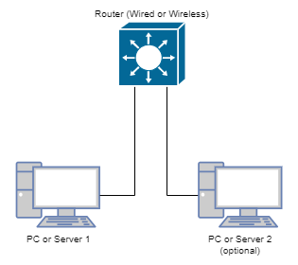

NOTE: This is a very basic lab with regards to network setup. All you need is basic network connectivity. If you are using Setup Option 2, I recommend that both PCs or Servers are on the same LAN.

## Setup Option 1 (1 PC or Server)

If you only have 1 PC or Server and want to run through the entire lab, all you will need to do is create 2 PBX VMs in VirtualBox. You will then need to run 4 MicroSIP softphones (2 registered to VM 1, and 2 registered to VM 2).

### System Requirements

#### Hardware

* 1 – Router (Wired or Wireless)
* 1 – PC or Server capable of running 2 FreePBX VMs in VirtualBox
  + CPU: 1 Core min of i5 Class or Better
  + RAM: 8GB
  + HDD: 80GB
  + NIC: 1 NIC (Ethernet or Wireless)

#### Software

* 1 – VirtualBox Instance
  + Supported OSes can be found [here](https://www.virtualbox.org/manual/ch01.html#hostossupport).
* 2 – FreePBX VM Distros (below is per VM)
  + - CPU: 1 vCPU
    - RAM: 2GB
    - HDD: 20GB
    - NIC: 1 NIC (Ethernet or Wireless)
* 4 – MicroSIP Softphones

## Setup Option 2 (2 PCs or Servers)

If you have 2 PCs or Servers and want to run through the entire lab, you will create 1 PBX VM in VirtualBox on each PC or Server. You will then need to run 2 MicroSIP softphones on each of the PCs or Servers and register them to their respective PBX. I would recommend keeping all PCs or Servers on the same LAN.

### System Requirements

#### Hardware

* 1 – Router (Wired or Wireless)
* 2 – PCs or Servers capable of running 1 FreePBX VMs in VirtualBox (below is per PC or Server)
  + CPU: 1 Core min of i5 Class or Better
  + RAM: 4GB
  + HDD: 40GB
  + NIC: 1 NIC (Ethernet or Wireless)

#### Software

Below is per PC or Server

* 1 – VirtualBox Instance
  + Supported OSes can be found [here](https://www.virtualbox.org/manual/ch01.html#hostossupport).
* 1 – FreePBX VM Distros (below is per VM)
  + - CPU: 1 vCPU
    - RAM: 2GB
    - HDD: 20GB
    - NIC: 1 NIC (Ethernet or Wireless)
* 2 – MicroSIP Softphones

# Install VirtualBox On Your Machine

Follow the installation instructions specific to your machine [here](https://www.virtualbox.org/manual/ch02.html).

* [Here](https://www.youtube.com/watch?v=IR1Jl4TMs7I&list=PL0TL-g5HVlo1Y88wngU3ZWJExKg6Np1OI&index=1) is a video by Patrick Kinane that shows the VirtualBox installation process for a Windows 10 PC. VirtualBox install starts at 3:43.

# Create the FreePBX VM

Follow the steps below.

* [Here](https://www.youtube.com/watch?v=saGD89Y58h4&list=PL0TL-g5HVlo1Y88wngU3ZWJExKg6Np1OI&index=2) is a video by Patrick Kinane that shows how to download the FreePBX Distro and Create the VM on VirtualBox.
* [Here](https://freepbx-guide.readthedocs.io/en/latest/preparing_the_environment.html) is the guide I used to walk you through the process.
* [Here](https://www.freepbx.org/downloads/) is the FreePBX Distro site.

## Download the FreePBX Distro

1. Download the FreePBX Distro [here](https://www.freepbx.org/downloads/).

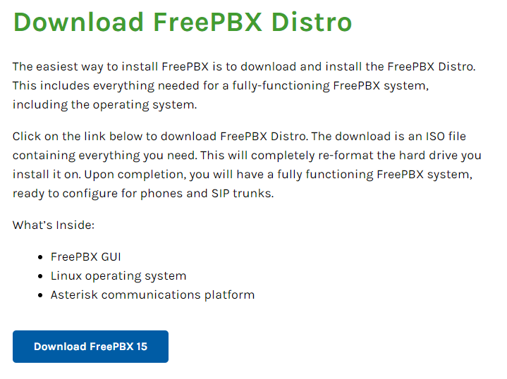

1. Fill in the form required to download the Distro.

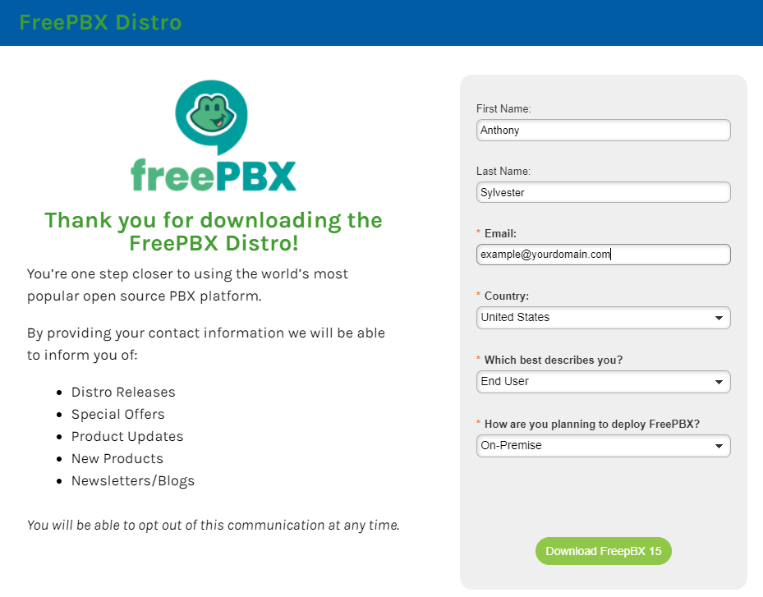

## Create the FreePBX VM in VirtualBox

NOTE: If you’re following Option 1, you will need to create 2 VMs. Follow the same process for both VMs but change the VM name to include the “Group #” at the end. Ex. FreePBX-Lab01 for Group 01 and FreePBX-Lab02 for Group 02.

1. Click ‘New’.



1. Type in a name for your new virtual machine. Let’s name it “FreePBX-Lab”.
2. Under the ‘Type’ drop down menu, select ‘Linux’.
3. Under the ‘Version’ drop down menu, select ‘Other Linux’.
4. Press ‘Next’.

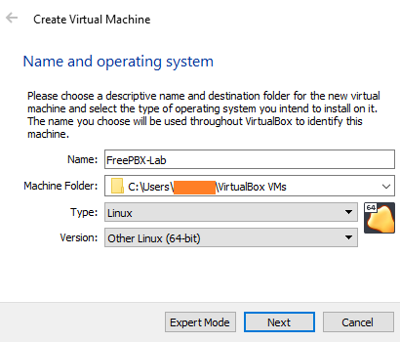

1. On this next screen, you can give your virtual machine as much RAM as you want. I’d recommend giving it about 2G (2048MB) of RAM–this way you can boot your FreePBX VM up and down quickly.
2. Press ‘Next’.

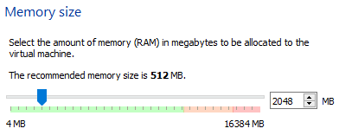

1. Select ‘Create a virtual hard disk now’ for Hard disk.
2. Press ‘Create’

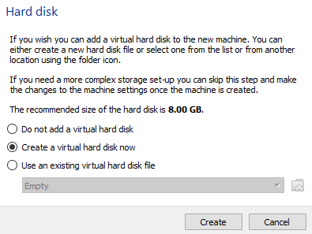

1. Choose ‘VDI (VirtualBox Disk Image)’ for Hard disk file type.
2. Press ‘Next’.

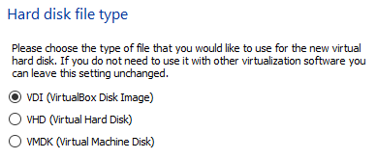

1. Select ‘Dynamically allocated’ for Storage on physical hard disk.
2. Press ‘Next’.

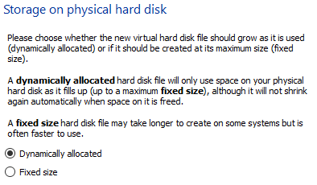

1. Leave the default file location.
2. Press ‘Create’.

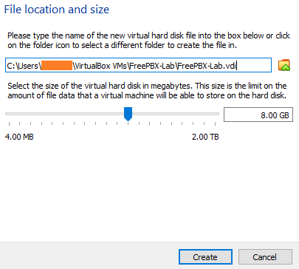

1. Click on your newly created VM.



1. Click on Settings.



1. Click on Storage.

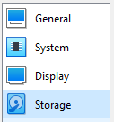

1. Click on the storage device ‘Empty’.

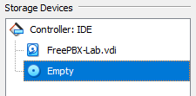

1. Click on the CD icon to the right of the Optical Drive drop-down option.

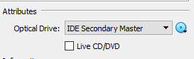

1. Click on ‘Choose a disk file…’.
2. Select the FreePBX Distro ISO file you just downloaded. (SNG7-FPBX-64bit-2002-2.iso)
3. Click on Network

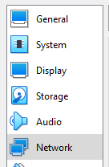

1. Select ‘Bridged Adapter’ from the Attached to drop-down.
2. Select the network adapter you want the VM to use. If you’re hardwired, use your ethernet adapter. If you only have a wireless connection, use your wireless adapter.

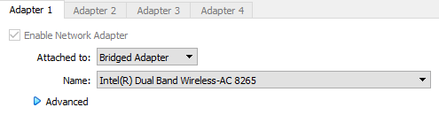

1. Click ‘OK’
2. Click on Start to start your VM.



1. When asked to select a start-up disk, choose the ISO file then press ‘Start’.

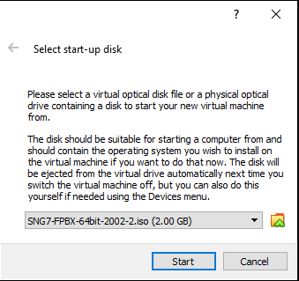

## Configuring The VM

1. Select ‘FreePBX 15 Installation (Asterisk 16) – Recommended’

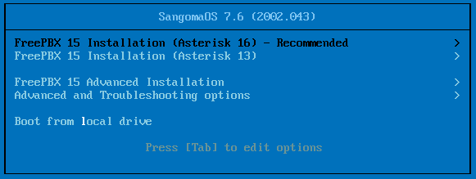

1. Select ‘Graphical Installation – Output to VGA’

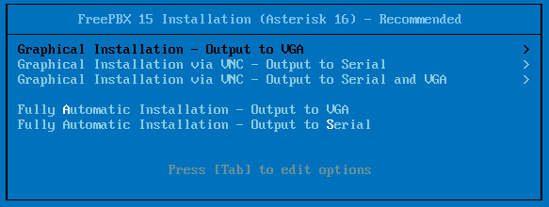

1. Select ‘FreePBX Standard’.

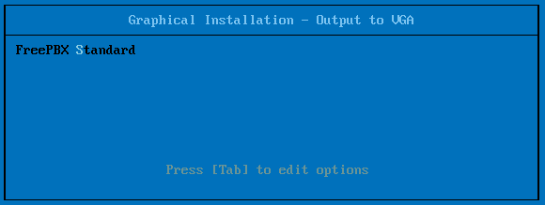

1. Wait until the User Settings page appears.
2. Click on ‘Root Password’.

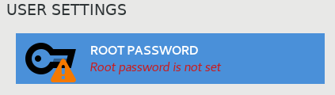

1. Enter in the root password assigned to your group. It should be ‘ciscoXX’ without quotes, where “XX” is your 2-digit group number.
2. Click ‘Done’.

NOTE: You may have to press ‘Done’ twice because the password is weak.

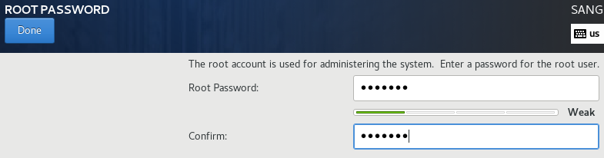

1. Once the system prompts for a ‘Reload’ it has finished the installation. Before clicking the reload button, we need to remove the ISO file.
2. Click on Settings.



1. Click on Storage.



1. Click on the storage device ‘SNG7-FPBX-64bit-2002-2.iso’.

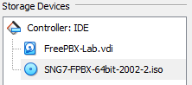

1. Click on the CD icon to the right of the Optical Drive drop-down option.



1. Click on ‘Remove Disk from Virtual Drive’.
2. Click ‘OK’.
3. Click ‘Reboot’.

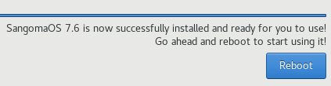

1. If your system runs into an issue, close the VM window and select ‘Power off the machine’.

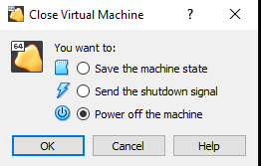

1. Move on to the next part once you arrive at the FreePBX login prompt.

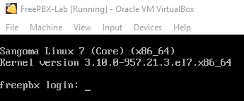

# Configure FreePBX CLI

* [Here](https://www.youtube.com/watch?v=Px7oolvVnJs&list=PL0TL-g5HVlo1Y88wngU3ZWJExKg6Np1OI&index=3) is a video by Patrick Kinane that shows how to configure the FreePBX VM via CLI.
* NOTE: This video does not show the process of finding out what IP your VM has received. You will need to follow the guide for that part.
* [Here](https://wiki.freepbx.org/display/PPS/How+to+set+Network+Settings+from+the+CLI) is the guide I used for configuring the static IP on the FreePBX VM.

1. Login to the root account using the password you created during initial setup. (XX is your group number)
   1. Username: root
   2. Password: ciscoXX
2. By default, the VM NIC is set to DHCP. To find out what IP address the VM has received, you can issue the following command:

Ifconfig eth0

1. The IP address that follows inet is the IP Address your VM has received. Use this in step 7 as <Your VM IP Address>.
   1. Ex. inet 10.0.10.101
2. The subnet mask that follows netmask is the subnet mask your VM has received. Use this in Step 7 as <Your VM Network Subnet Mask>.
   1. Ex. netmask 255.255.255.0
3. You will need to determine the Default Gateway Address. This is the IP address of the router your VM is connected to. Use this in Step 7 as <Your VM Default Gateway Address>.
4. Access the file that handles the system’s network info.

nano /etc/sysconfig/network-scripts/ifcfg-eth0

1. Change, and add if necessary, the following parameters to set the IP, Subnet Mask and Default Gateway Address. Do not change other parameters if there are any.

BOOTPROTO=”static”

ONBOOT=”yes”

IPADDR=<Your VM IP Address>

GATEWAY=<Your VM Default Gateway Address>

NETMASK=<Your VM Network Subnet Mask>

1. Example:

BOOTPROTO=”static”

ONBOOT=”yes”

IPADDR=10.0.10.101

GATEWAY=10.0.10.1

NETMASK=255.255.255.0

1. Press Ctrl-O to save the configuration file.



1. Press Enter to complete the save and then Ctrl-X to exit the editor.
2. Run following command to apply your network settings.

service network restart

1. Once the service restarts, verify that the interface has taken the network settings.

ifconfig eth0

# Access the PBX CLI via SSH

* [Here](https://www.youtube.com/watch?v=Px7oolvVnJs&list=PL0TL-g5HVlo1Y88wngU3ZWJExKg6Np1OI&index=3) is a video by Patrick Kinane that shows how to access the FreePBX VM CLI via SSH using PuTTY. Skip to 4:24.

Verify connectivity to the PBX Command Line Interface (CLI).

1. Use a terminal emulator, such as PuTTY, and establish an SSH connection to your PBX.
2. When asked to accept the server’s host key, click ‘Yes’.
3. Login using the root credentials. (XX is the group number)
   1. Username: root
   2. Password: ciscoXX
4. After successfully logging in to the VM using PuTTY, minimize the VirtualBox VM window. Do not close the VM window because that will shut down the VM.
5. Going forward, you will use PuTTY whenever you want to access the CLI of the FreePBX VM.

# Configure FreePBX GUI

* [Here](https://www.youtube.com/watch?v=QULtXqTUpKc&list=PL0TL-g5HVlo1Y88wngU3ZWJExKg6Np1OI&index=4) is a video by Patrick Kinane that shows how to configure the FreePBX VM via the Web GUI.

FreePBX is just the Web GUI that is used to make configuring the console-based Asterisk PBX system easier and more user friendly. You still have the ability to configure the Asterisk PBX from the CLI. However, I do not recommend messing with the VM via CLI.

When working in FreePBX, you will be able to make numerous system changes. However, these changes will not be applied to your PBX system until you click the red Apply Config button, located at the top-right of the FreePBX page. This feature is helpful because it allows you to make sure that all changes have been completed before applying them.

## 1. System

1. Access the FreePBX Web GUI:

http://<Your VM IP Address>

1. Set the following fields (XX is your group number):
   1. Username: admin
   2. Password: ciscoXX
   3. Notifications Email Address: fake@fake.com
2. Click on Setup System in the lower-right corner once you’re done.

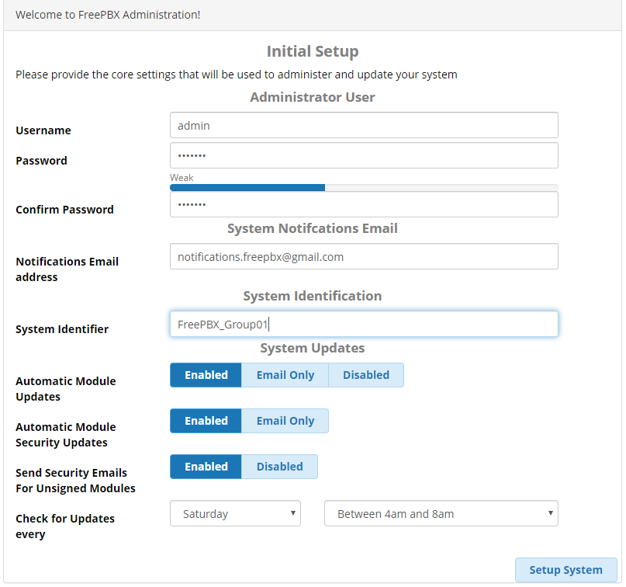

1. Click on the *FreePBX Administration* icon and login using the admin credentials you just created.

 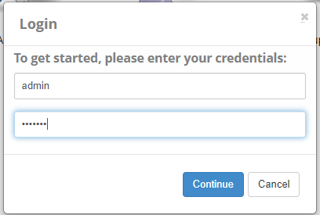

1. After logging in: SKIP the system activation and any other pop-ups.

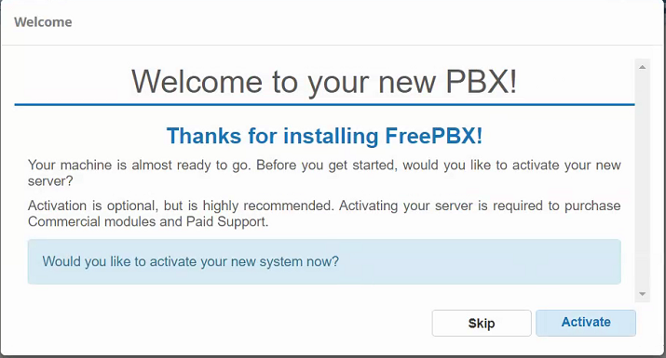



1. Upon first login, you’ll have to choose the language and time zone you’re using. Select the following:
   1. Sound Prompts Language: English
   2. System Language: English (United States)
   3. Timezone: America/New_York
2. Click submit when you’re done.

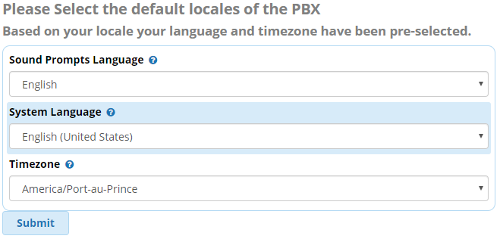

1. ABORT the Sangoma Smart Firewall, and SKIP any pop-ups.

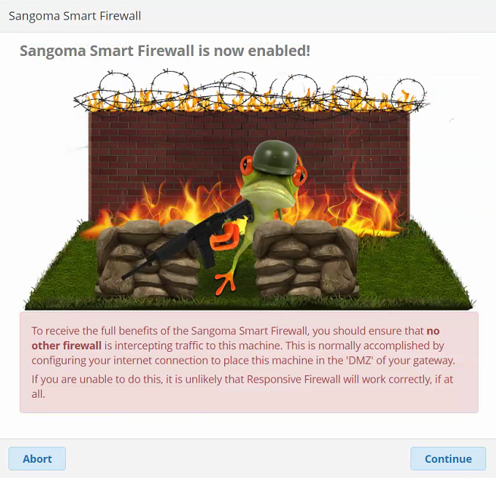

1. Click on **Settings** then choose **Asterisk SIP Settings** from the drop down.

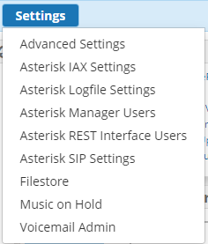

1. Enter the following fields under the NAT Settings section.
   1. External Address: <Your VM IP Address>
      1. NOTE: This is the address that the clients will use if NAT is enabled and detected. Clients are softphones in our case. You want to make sure that this field is configured with the static IP assigned to your PBX.
   2. Local Networks: <Your VM Network in CIDR Notation>
      1. Here is a calculator for you to obtain your network address in CIDR notation.
      2. Enter the IP Address of your VM in the IP Address box.
      3. Select the Subnet Mask of your VM from the CIDR Netmask box.
      4. Copy the text in ‘Net: CIDR Notation’ box. This is <Your VM Network in CIDR Notation>

Example:

VM IP Address: 10.0.10.101

CIDR Netmask: 255.255.255.0

Net: CIDR Notation was 10.0.10.0/24

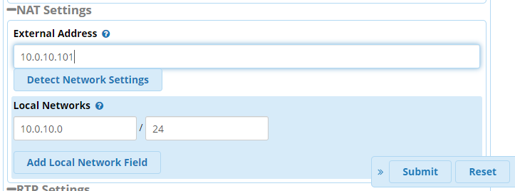

1. Click Submit in the lower-right corner when done.
2. Click Apply Config at the top-right corner. This will apply all the config changes you’ve made so far in FreePBX, to the Asterisk PBX system.



## 2. Internal Extensions

* [Here](https://www.youtube.com/watch?v=Y-O0uzGGiDI&list=PL0TL-g5HVlo1Y88wngU3ZWJExKg6Np1OI&index=5) is a video by Patrick Kinane that shows how to configure the internal extensions.

1. Click on Applications, and then Extensions.

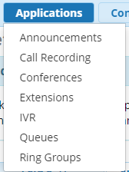

1. Click the Add Extension drop-down and select the “Add New SIP [chan_pjsip] Extension” option.
2. Enter the following fields in the General Tab (XX is your group number):
   1. 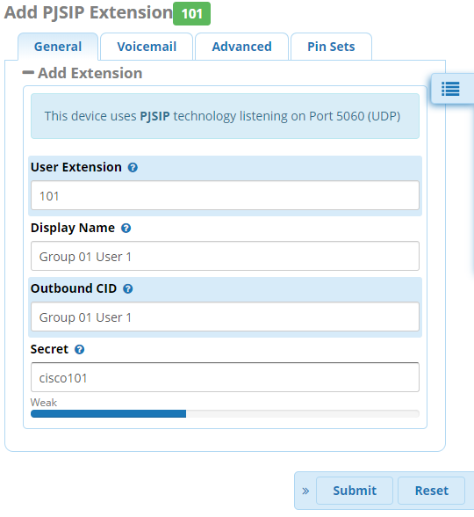User Extension: 101
   2. Display Name: Group XX User 1
   3. Outbound CID: Group XX User 1
   4. Secret: cisco101
3. Click Submit when you’re done.
4. Click on the Edit icon to the right of the extension we just created.

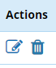

1. Enter the following fields in the Voicemail Tab:
   1. Enabled: Yes
   2. Voicemail Password: 1234
   3. Require From Same Extension: No
   4. Play CID: Yes
2. Click Submit when you’re done.
3. Click Apply Config.



1. Click the Add Extension drop-down and select the “Add New SIP [chan_pjsip] Extension” option.

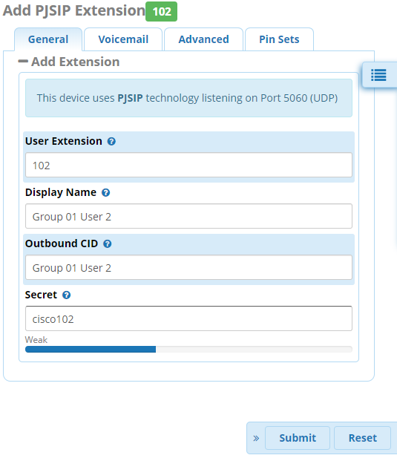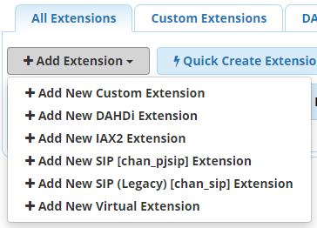

1. Enter the following fields (XX is your group number):
   1. User Extension: 102
   2. Display Name: Group XX User 2
   3. Outbound CID: Group XX User 2
   4. Secret: cisco102
2. Click Submit when you’re done.
3. Click on the Edit icon to the right of the extension we just created.



1. Enter the following fields in the Voicemail Tab:
   1. Enabled: Yes
   2. Voicemail Password: 1234
   3. Require From Same Extension: No
   4. Play CID: Yes
2. Click Submit when you’re done.
3. Click Apply Config.



## 3. Install MicroSIP and test your system

* [Here](https://www.youtube.com/watch?v=WbUjeI00bSU&list=PL0TL-g5HVlo1Y88wngU3ZWJExKg6Np1OI&index=6) is a video by Patrick Kinane that shows how to install, configure, register, and test the MicroSIP softphones.
* [Here](https://www.microsip.org/downloads) is the MicroSIP download page.

### Installation and Setup of MicroSIP

1. Download the MicroSIP softphone portable.zip from the downloads page [here](https://www.microsip.org/downloads).

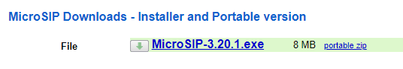

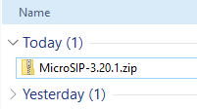

1. Unzip the folder and append ‘-1’ at the end of the new folder name.

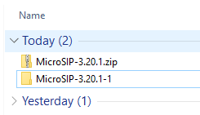

1. If you are following Option 1 (1 PC or Server), you will need to repeat this unzipping process and append ‘-2’, ‘-3’, and ‘-4’ for a total of 4 unzipped folders. This will allow you to have 4 separate instances of MicroSIP running at the same time.
2. If you are following Option 2 (2 PCs or Servers), you will need to repeat this unzipping process and append ‘-2’ for a total of 2 unzipped folders per PC or Server. This will allow you to have 2 separate instances of MicroSIP running at the same time per PC or Server.
3. To start each instance of MicroSIP, go into the newly renamed folder and run the microsip.exe file.
   1. NOTE: In order to completely close the application, select the drop down in the top right corner and click on ‘Exit’. If you click the red X in the top right of the application, the program will just run in the background and can be opened from the hidden icons in the task bar.
4. If prompted, allow MicroSIP to access your network.
5. Configure the MicroSIP softphones by clicking on the drop down in the top right corner and clicking on ‘Add Account…’.
   1. Account Name: Extension Number (101 or 102)
   2. SIP Server: VM IP Address
   3. SIP Proxy: VM IP Address
   4. Username: Extension Number (101 or 102)
   5. Domain: VM IP Address
   6. Password: Extension Password (cisco101 or cisco102)
   7. Display Name (XX is your group number): Group XX User (1 or 2)
   8. Click ‘Save’
6. Verify that the softphone has successfully registered by checking if the lower left corner says ‘Online’.
   1. If this doesn’t chow up as ‘Online’, verify that all settings were put in correctly and that there aren’t any typos.
7. The Account Name (Extension Number) should appear in the lower right corner.
8. To change the speaker and mic, click on the drop down in the top right and click on ‘Settings’.
9. Choose the Speaker you want to use.
10. Choose the Microphone you want to use.
11. Click ‘Save’.

### Test the system – Basic Calling

Since there are 2 extensions in the system, you should be able to call between the 2 users.

* 1. Ext 101 – call Ext 102.
  2. Ext 102 – answer the call.
     1. Successful (Y/N): ______
  3. Ext 102 – call Ext 101.
  4. Ext 101 – answer the call.
     1. Successful (Y/N): ______

### Test the system - Voicemail

Since the 2 extensions in the system have voicemail, you should be able to call and leave a message.

1. Ext 101 – call Ext 102.
2. Ext 102 – decline the call.
3. Ext 101 – leave a voicemail and hang-up.
4. Successful (Y/N): ______
5. Ext 102 – call Ext 101.
6. Ext 101 – decline the call.
7. Ext 102 – leave a voicemail and hang-up.
8. Successful (Y/N): ______

Now that we have configured, registered, called, and left voicemails between our 2 internal extensions, we need to make sure that each user can check their voicemail. If you used a personal email when setting up an extension, check your email to see if you’ve received the email with the voicemail audio file.

Here is how you can check your voicemail from the softphone.

1. Dial *97 and press Enter.
2. Follow the prompts to listen to your voicemail messages.

## 4. SIP Trunks

* [Here](https://www.youtube.com/watch?v=Sz39uZRpU04&list=PL0TL-g5HVlo1Y88wngU3ZWJExKg6Np1OI&index=7) is a video by Patrick Kinane that shows how to configure the SIP trunks between PBXs.

Now we are going to configure a SIP trunk between our PBX and another group’s PBX. A SIP Trunk is used to send VoIP signaling over an IP-based network to another system. This is typically done between a business’s PBX and their VoIP Service Provider.

[Here is SIP Trunking info](https://www.sip.us/blog/latest-news/sip-trunking-101-the-fundamentals/).

[Here is some VoIP Service Provider info](https://www.webopedia.com/TERM/V/voip_service_provider.html).

1. Click on **Connectivity** and choose **Trunks** from the drop-down menu.

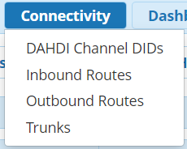

1. Click **+Add Trunk** and select **+Add SIP [chan_pjsip] Trunk**

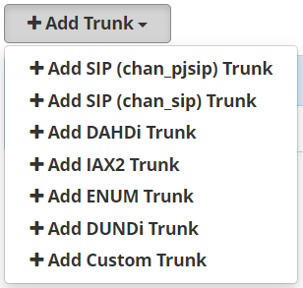

1. Enter the following fields in the General Tab:
   1. Trunk Name: Trunk_OO_EE
      1. Replace “OO” with the ODD 2-digit group number.
      2. Replace “EE” with the EVEN 2-digit group number.



* 1. Outbound CallerID: “Group XX” <+1555666XX00>
     1. Replace “XX” with your 2-digit group number.



1. Enter the following fields in the **pjsip Settings** Tab:
   1. Secret: ciscoOOEE
      1. Replace “OO” with the ODD 2-digit group number.
      2. Replace “EE” with the EVEN 2-digit group number.
      3. Example: cisco0102
   2. Authentication: Both
   3. Registration: None
   4. SIP Server: <IP Address of another group’s PBX>
      1. Example: 10.0.10.102

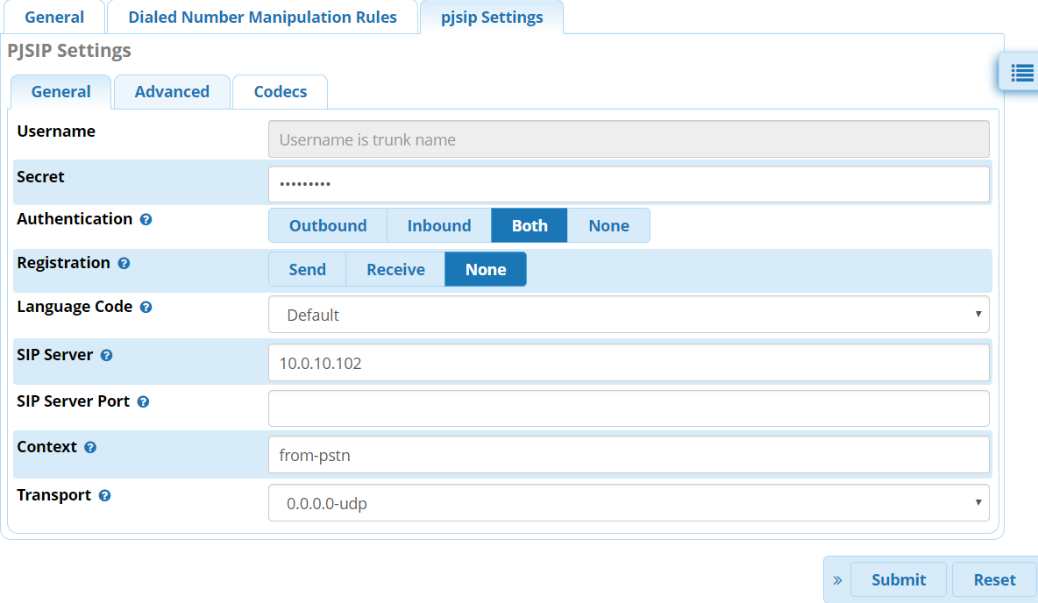

1. Click Submit when you’re done.
2. Click Apply Config in the top-right corner.



## 5. Outbound Calling

* [Here](https://www.youtube.com/watch?v=Sz39uZRpU04&list=PL0TL-g5HVlo1Y88wngU3ZWJExKg6Np1OI&index=7) is a video by Patrick Kinane that shows how to configure outbound calling between PBXs. Skip to 3:27.

Now that we have established a SIP Trunk between our PBX and another group’s PBX, we need to create Outbound Routes that tell our PBX when to send calls across the SIP Trunk.

### Create an Outbound Route

1. Click on Connectivity and choose Outbound Routes from the drop-down menu.

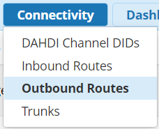

1. Click +Add Outbound Route



1. Enter the following fields in the Route Settings Tab:
   1. Route Name: To Group ZZ
      1. Replace “ZZ” with the 2-digit group number of the group you established the trunk with.



* 1. Trunk Sequence for Matched Routes: Trunk_OO_EE
     1. Replace “OO” with the ODD 2-digit group number.
     2. Replace “EE” with the EVEN 2-digit group number.

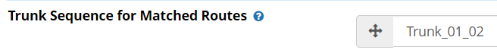

1. Enter the following fields in the Dial Patterns Tab:
   1. Click the Plus (+) on the right of the first entry so that there is a total of 5 blank dial pattern entries.

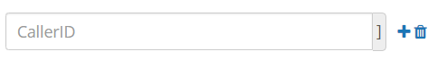

* 1. Entry 1 (+1 10-Digit Dialing)
     1. Match Pattern: +1NXXXXXXXXX



* 1. Entry 2 (1 10-Digit Dialing)
     1. Prepend: +
     2. Match Pattern: 1NXXXXXXXXX



* 1. Entry 3 (10-Digit Dialing)
     1. Prepend: +1
     2. Match Pattern: NXXXXXXXXX



* 1. Entry 4 (7-Digit Dialing)
     1. Prepend: +1555
     2. Match Pattern: NXXXXXX



* 1. Entry 5 (4-Digit Dialing)
     1. Prepend: +1555666
     2. Match Pattern: **ZZ**XX
        1. Replace “ZZ” with the 2-digit group number that you established the trunk with. Keep the “XX”



* 1. [Here is the Outbound Routes User Guide for FreePBX](https://wiki.freepbx.org/display/FPG/Outbound+Routes+Module+User+Guide).

1. Click Submit when you’re done.
2. Click Apply Config in the top-right corner.



Example: If you’re in Group 1 and dial “0200” (trying to call group 2’s main line) then the system will match dial pattern entry 4. The system will then prepend “+1555666” to the dialed number and send it out the SIP Trunk to Group 2. In this case, the PBX will send “+15556660200” over the SIP Trunk.

## 6. Inbound Calling

* [Here](https://www.youtube.com/watch?v=Sz39uZRpU04&list=PL0TL-g5HVlo1Y88wngU3ZWJExKg6Np1OI&index=7) is a video by Patrick Kinane that shows how to configure inbound calling between PBXs. Skip to 5:26.

We are going to make it so that when your PBX receives a call to your group’s public number, it rings both internal extensions. We will also make it so someone can call each user using their own public number.

### Create a Ring Group

1. Click on Applications and choose Ring Groups from the drop-down menu.

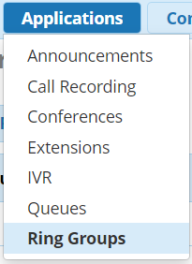

1. Click +Add Ring Group



1. Enter the following in the fields:
   1. Ring-Group Number: 100
   2. Group Description: Ring Ext 101 and 102
   3. Extension List:
      1. 101
      2. 102
   4. Ring Strategy: ringall

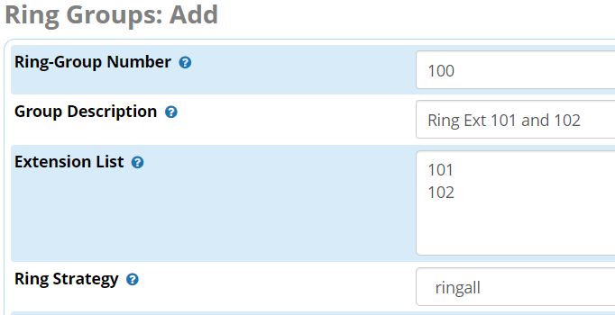

* 1. Destination If No Answer: Terminate Call
     1. Hangup

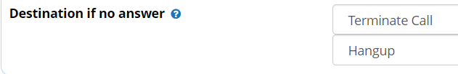

1. Click Submit when you’re done.
2. Click Apply Config in the top-right corner.



### Create an Inbound Route – Group’s Number

1. Click on Connectivity and choose Inbound Routes from the drop-down menu.

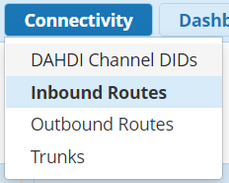

1. Click +Add Inbound Route



1. Enter the following in the fields:
   1. Description: Main Line
   2. DID Number: +1555666XX00
      1. Replace “XX” with your 2-digit group number.
      2. Ex. Group 1 would use: +15556660100
   3. Set Destination: Ring Groups
      1. 100 Ring Ext 101 and 102
2. Click Submit when you’re done.
3. Click Apply Config in the top-right corner.



### Test the system – Main Line

Put the Outbound and Inbound Routes to work.

At this point, we now have our system configured so that if it receives a call to your group’s public number (Ex. Group 1’s public number is +15556660100), then both extension 101 and 102 in group 1 will ring. If the call isn’t answered within 20 seconds, the call will be terminated.

Call your partner Group’s main line using the following different methods (Replace XX with your partner’s group number):

* 1. 4-digit dialing (XX00)
     1. Successful (Y/N): _____
  2. 7-digit dialing (666XX00)
     1. Successful (Y/N): _____
  3. 10-digit dialing (555666XX00)
     1. Successful (Y/N): _____
  4. 1 10-digit dialing (1555666XX00)
     1. Successful (Y/N): _____
  5. +1 10-digit dialing (+1555666XX00)
     1. Successful (Y/N): _____

### Create an Inbound Route – User 1’s DID Number

1. Click on Connectivity and choose Inbound Routes from the drop-down menu.



1. Click +Add Inbound Route



1. Enter the following in the fields:
   1. Description: User 1
   2. DID Number: +1555666XX01
      1. Replace “XX” with your 2-digit group number.
      2. Ex. Group 1 would use: +15556660101
   3. Set Destination: Extensions
      1. 101 Group 01 User 1
2. Click Submit when you’re done.
3. Click Apply Config in the top-right corner.



### Create an Inbound Route – User 2’s DID Number

1. Click on Connectivity and choose Inbound Routes from the drop-down menu.



1. Click +Add Inbound Route



1. Enter the following in the fields:
   1. Description: User 2
   2. DID Number: +1555666XX02
      1. Replace “XX” with your 2-digit group number.
      2. Ex. Group 1 would use: +15556660102
   3. Set Destination: Extensions
      1. 102 Group 01 User 2
2. Click Submit when you’re done.
3. Click Apply Config in the top-right corner.



### Test the system – User DIDs

Put the user’s Inbound Routes to work.

At this point, we now have our system configured so that if it receives a call, it checks the different inbound routes for matches and sends the caller to the specified destination.

Call your partner Group user’s public number using the following different methods (Replace XX with your partner’s group number):

1. 4-digit dialing (XX01 and XX02)
   1. Successful (Y/N): _____
2. 7-digit dialing (666XX01 and 666XX02)
   1. Successful (Y/N): _____
3. 10-digit dialing (555666XX01 and 555666XX02)
   1. Successful (Y/N): _____
4. 1 10-digit dialing (1555666XX01 and 1555666XX02)
   1. Successful (Y/N): _____
5. +1 10-digit dialing (+1555666XX01 and +1555666XX02)
   1. Successful (Y/N): _____

# References